CSE230 Final Questions Solution

Set: A

**Q01: [CO4] [20 Marks]**

In a box, there are 6 green balls, 4 yellow balls and a ball which can either be green or yellow with 50-50 chances (Not known with certainty). If you pick two balls at random from the box,

1. What is the probability that both the balls will be green? [3 marks]
2. What is the probability that the balls will be of the same colors? [6 marks]
3. What is the probability that the balls will be of different colors? [6 marks]
4. What is the probability that at most one ball will be green? [5 marks]

**Solution:**

1. **18/55 = 0.327272727**
2. **18/55 + 8/55 = 26/55 = 0.472727**
3. **1–26/55 = 29/55 = 0.527272727**
4. **1–18/55 = 37/55 = 0.627272727**

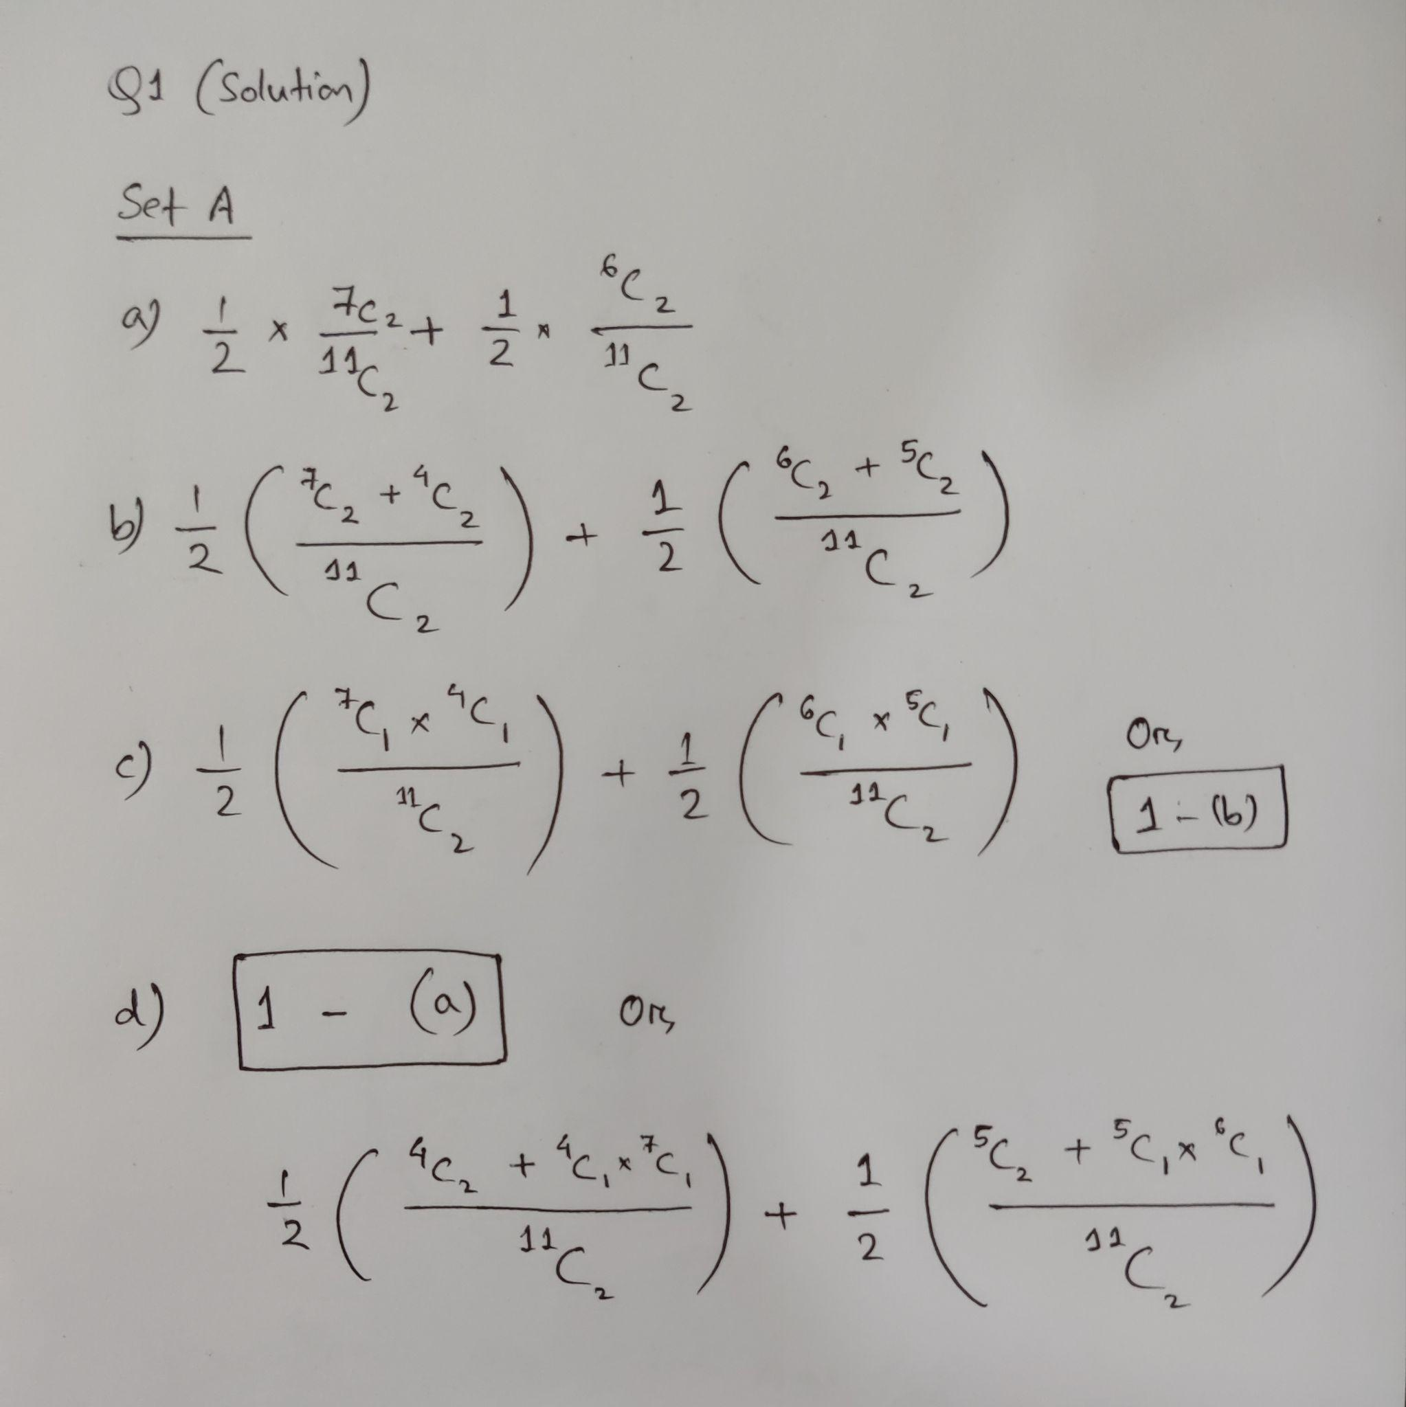

**Q02: [CO2] [20 Marks]**

1. A famous restaurant has introduced a combo meal, consisting of 4 types of rice, 5 types of side dishes, 4 types of salads, and some type of desserts. Among each item, the diner can select one for their meal.
   1. Suppose, 240 different types of combo meals can be prepared in this situation. How many types of desserts does the restaurant offer? [3 marks]
   2. On a particular day, the manager instructed the waiters to arrange the rice, salads, and desserts on a table serially. But, he wanted to keep the 4 types of rice separately (so they cannot be placed side by side), keeping a salad on one end and a side dish on the other end. How many ways are there to arrange the foods according to the instructions? [7 marks]
2. Tom loves playing with integers. He has picked up some distinct positive integers that are not larger than 30. According to Tom, there is an integer that is divisible by either 2 or 7. How many integers must have been picked by him? [5 marks]
3. Your friend has some fruits. Each of them is of distinct type. He randomly chooses a pair of fruits, each containing fruits of different kinds.
   1. If the total number of possible combinations were 91, how many fruits does your friend have?

[3 marks]

* 1. Will the number of possible combinations change from 91, if the count of each type of fruit had been more than 1? Give a proper explanation. [2 marks]

**Solution:**

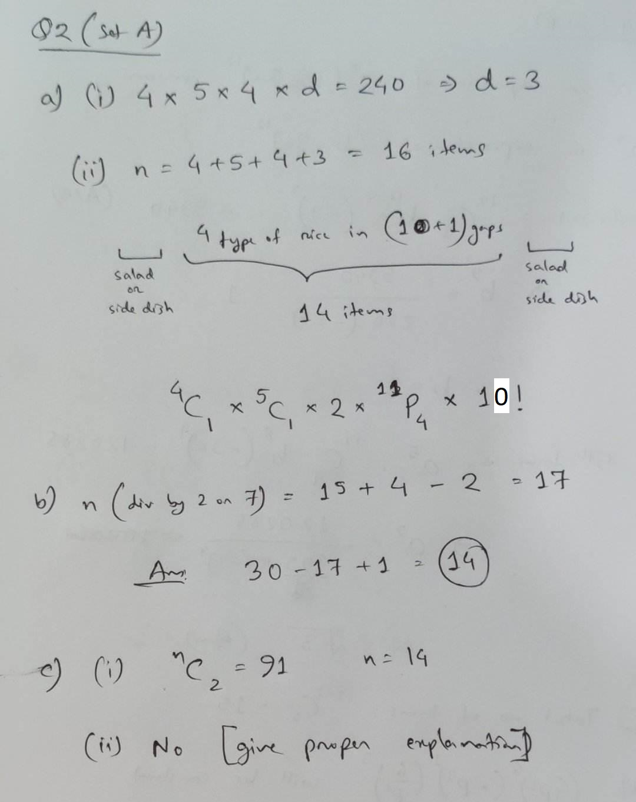

**In 2(c) i - if a student starts with nC2 * (n-2)C2 * (n-4)C2 * (n-6)C2 … = 91 and goes a bit deeper into a form like n! / 2^k .. he/she should be given marks as well.**

**Q03: [CO1] [20 Marks]**

1. Sue has two coins. One is fair, with a head on one side and a tail on the other. The second is a trick coin and has a tail on both sides. Sue picks up one of the coins at random and flips it.

Given that it lands tails up, find the probability that she picked up the fair coin. [6 marks]

1. In a factory, machines A, B and C are all producing metal rods of the same length. Machine A produces 35% of the rods, machine B produces 20% and the rest are produced by machine C. Of their production of rods, machines A, B and C produce 3%, 6% and 5% defective rods respectively.

Find the probability that a randomly selected rod is:

I. Produced by machine B and is defective [3 marks]

II. Not defective. [5 marks]

III. Given that a randomly selected rod is defective, find the probability that it was made by machine A.

**Solution:**

1. **(½ * ½)/(½ * ½ + ½ * 1) = ¼ / ¾ = 1/3** 
   1. **0.2 * 0.06 = 3/250 = 0.012**
   2. **1 – (0.35*0.03 + 0.2*0.06 + 0.45*0.05) = 191/200 = 0.955**
   3. **(0.35 * 0.03) / (1 – 0.955) = 7/30 = 0.23333333333333333**

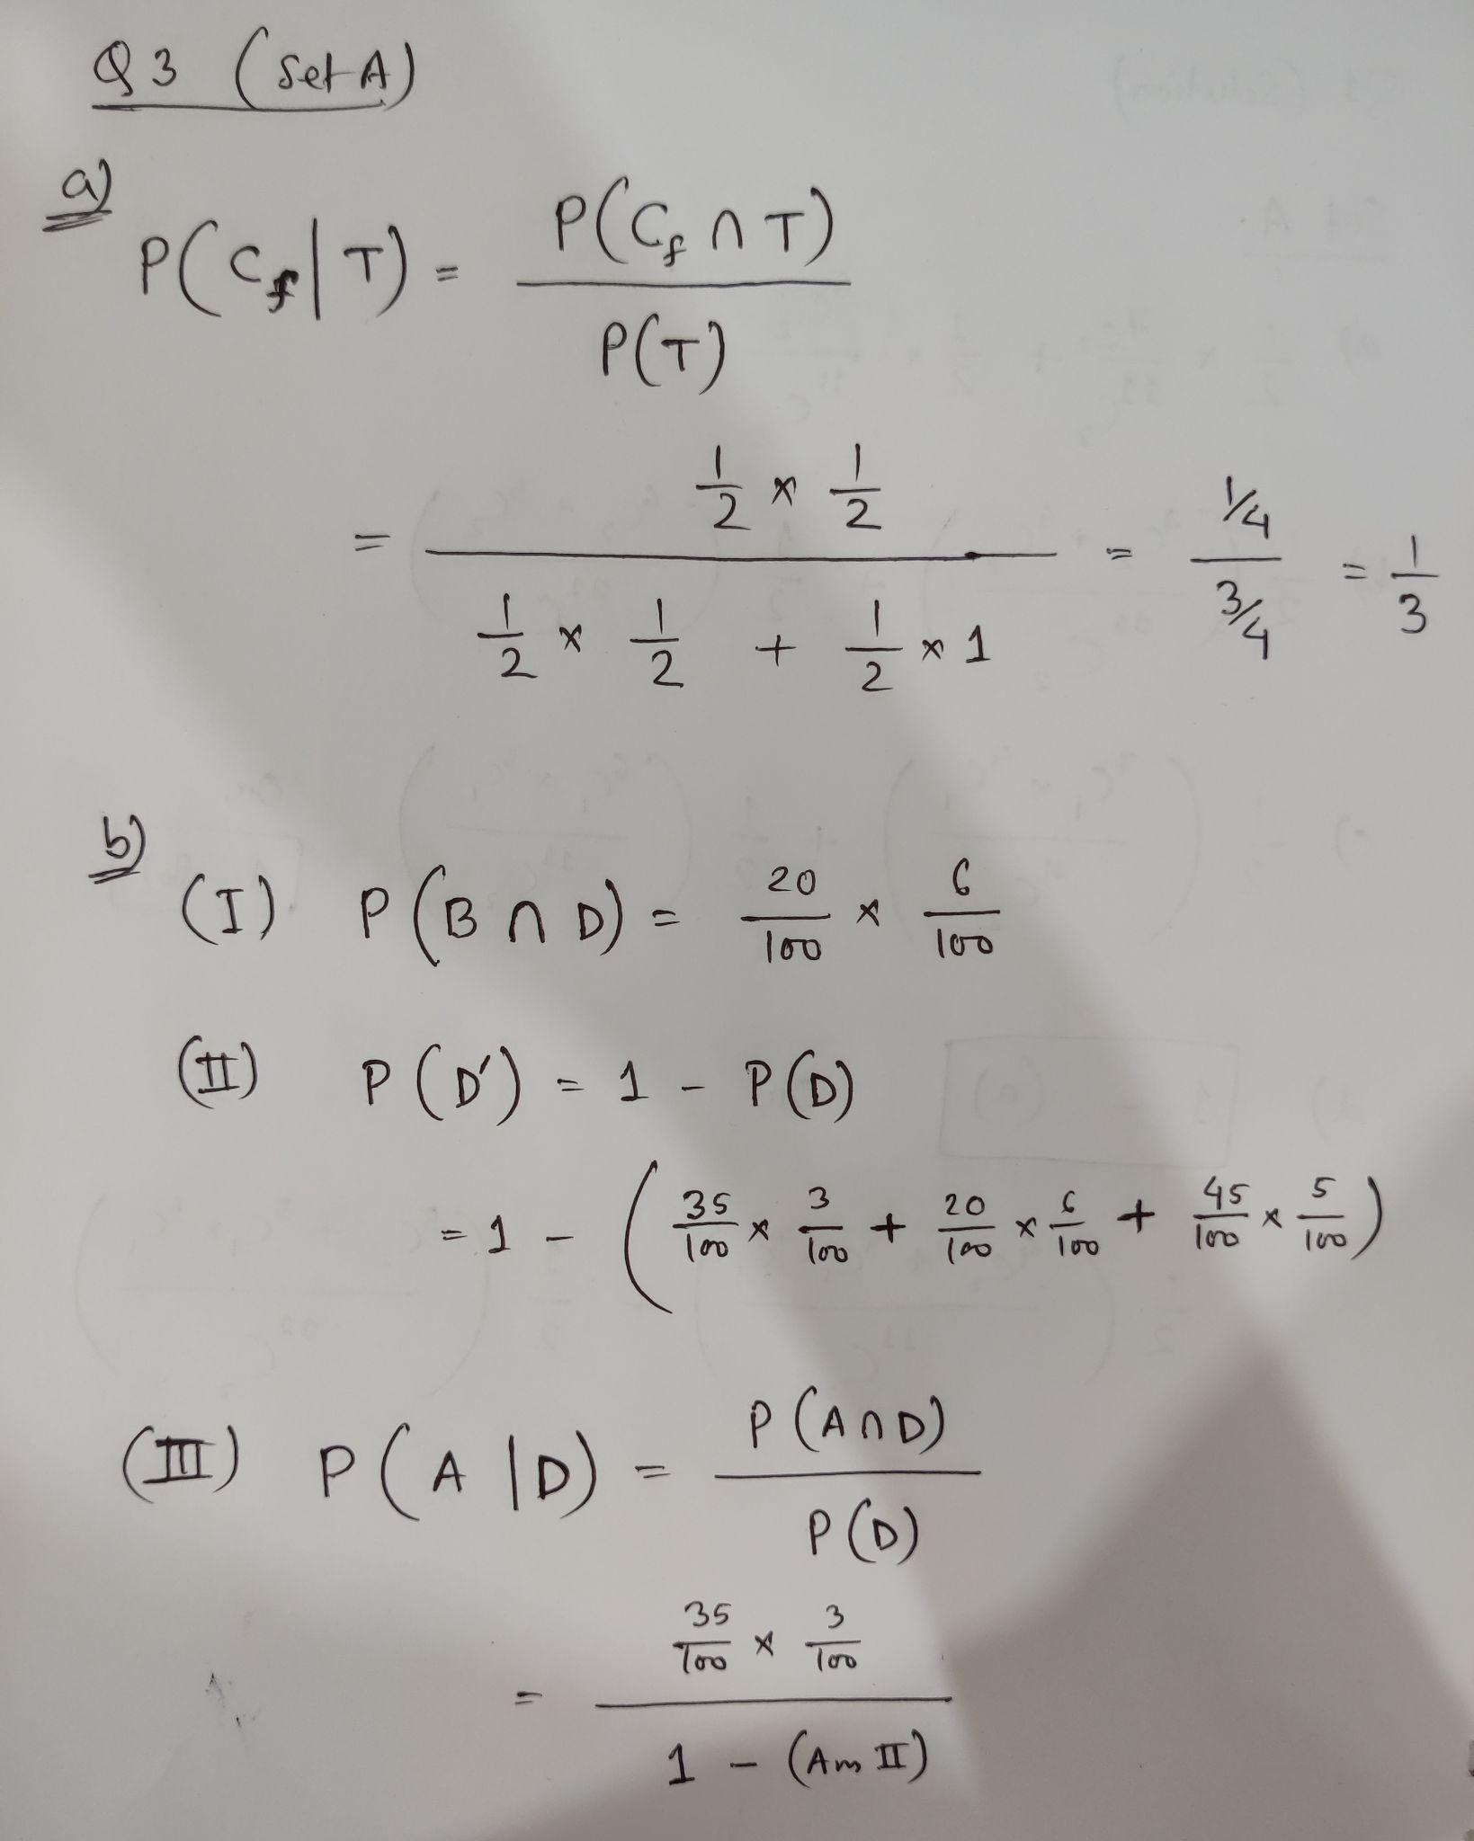

**Q04: [CO3] [20 Marks]**

Read the following equations:

$(Ax-4y^{2})^{7}$

$(1+2a-5b)^{4}$

$(3p^{3}-2p^{2}+\frac{5}{p^{5}})^{10}$

Answer the following questions considering the given equations:

1. If the coefficient of $x^{2}y^{10}$ is -86016, then what is the value of A from equation I

where $x,y>0$ and $x,y∈R$? [4 marks]

1. Find the $2^{nd}$ last term of $(Ax-4y^{2})^{13}$ using the binomial $r^{th}$ Term formula?

[Use the value of A from the previous question] [6 marks]

1. Find the total number of terms in the expansion of $(1+2a-5b)^{4}$. [3 marks]
2. Determine the value of the constant term in the expansion of $(3p^{3}-2p^{2}+\frac{5}{p^{5}})^{10}$ [7 marks]

**Solution:**

